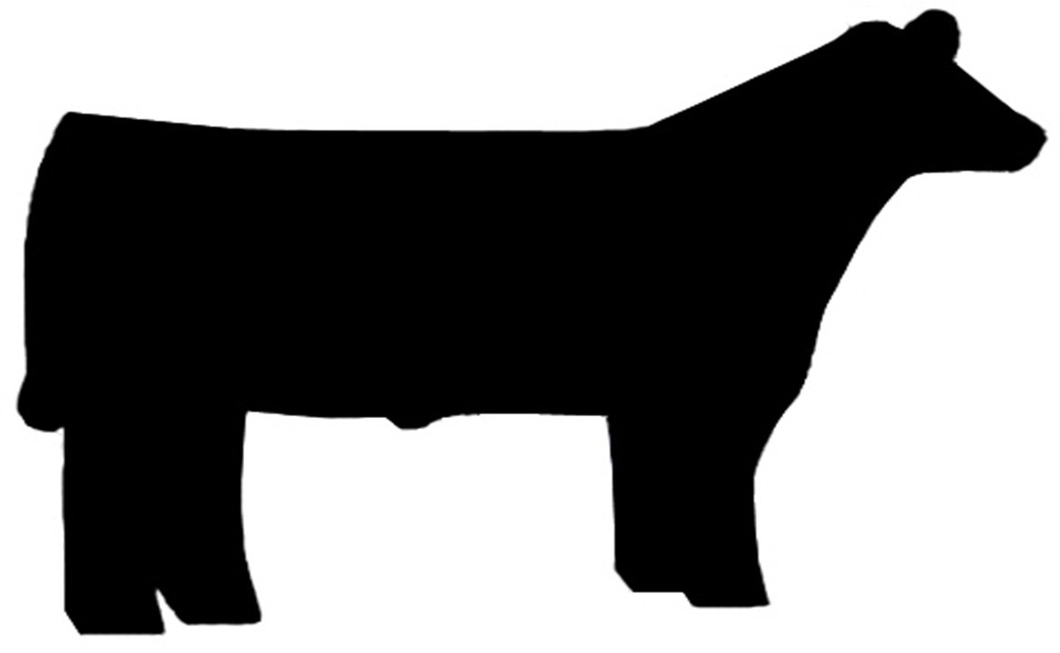

Stoughton Open Beef Show
Open to ages 8-99 Friday July 1st, 2022 5pm

*****UPDATE – ANYONE UNDER THE AGE OF 8 CAN SHOW BUT MUST BE ACCOMPANIED BY AN ADULT FOR OPEN BEEF SHOW.*****

Please mail to Jan Bakken, 2541 Door Creek Rd Stoughton, WI 53589 By May 31st.

Name

Address

Phone number

How many animal are you bringing (for junior exhibitors please put additional animals)

I will be coming in on Tuesday and staying until Sunday
or
I will be coming in Friday and leaving Friday

- All beef animals must have some form of ID. Ex. tattoo or RFID tag
- Junior heifer calves must be 4 months to show alone. March 6th or older
- Must provide your own bedding. Bedding must be disposed of before leaving
- Animals may be brought in on Tuesday with other junior show stock. IF ANIMALS COME IN ON TUESDAY THEY MUST STAY UNTIL SUNDAY RELEASE TIME OR open show beef may be brought in Friday for show and taken out Friday after show. NO JUNIOR STOCK CAN LEAVE ON FRIDAY NIGHT.
- Open Show animals may be stalled in barn pending space.
- Arrival may begin no earlier than 9AM Friday for animals leaving Friday.
- Wash racks will have designated times for use
- Classes will be done by weight for Breeding and Steer classes. Scales will open at 3pm Cow/calf pair will not weigh.
- All Chutes must be out by Saturday morning.
We will still run by junior show rule, NO Alcohol Allowed

